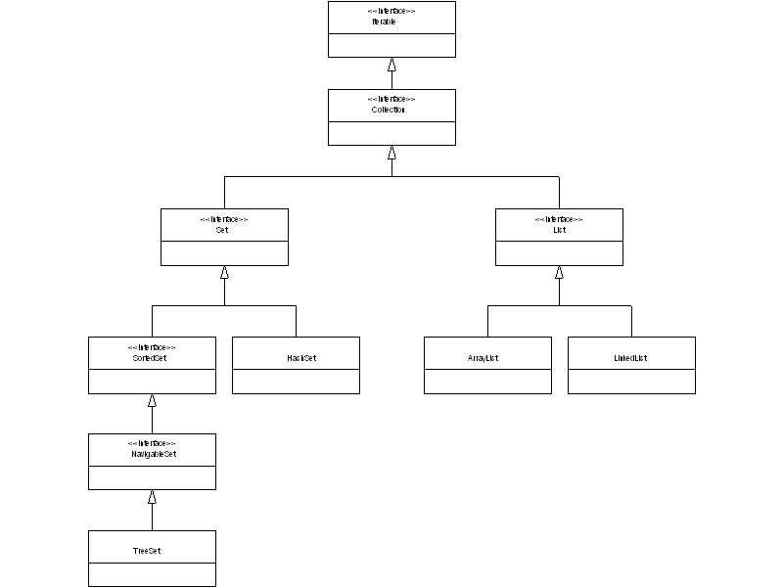

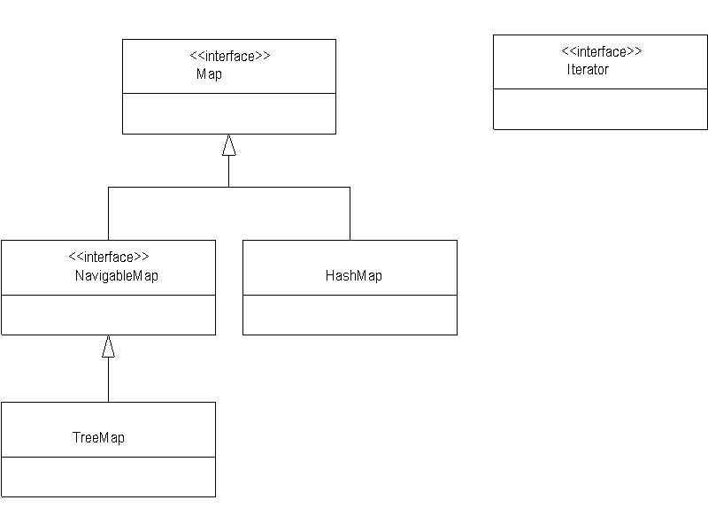

Ex3.

A) Both TreeSet and ArrayList implement the interface Collections. As they both implement Collections they bot must implement the all methods in collections. The code only uses methods that are in the collections interface therefore both TreeSet and ArrayList must implement them.

B) When adding the same string twice, TreeSet and ArrayList behave differently. If you add a duplicated element to TreeSet it doesn't actually add it. If you add a duplicated element to ArrayList however it just appends it to the end. It can be seen in the API documentation that these classes have different implementations of the add(E e) method:

ArrayList
add(E e)
Appends the specified element to the end of this list.

TreeList
add(E e)
Adds the specified element to this set if it is not already present.

Ex4.

A) HashSet will not add an element if the element already exists. It has a different implementation of add(E e).

Option are:
a: add an element to the collection
p: print the collection
m: display menu
Enter option> a
Enter string to add to collection> hello
Enter option> a
Enter string to add to collection> hello
Enter option> p
hello

B) HashSet implements Set, TreeSet implements SortedSet. As such the elements in the HashSet are not sorted whereas they are in TreeSet:

HashSet:
Option are:
a: add an element to the collection
p: print the collection
m: display menu
Enter option> a
Enter string to add to collection> b
Enter option> a
Enter string to add to collection> a
Enter option> p
b
a

TreeSet:
Option are:
a: add an element to the collection
p: print the collection
m: display menu
Enter option> a
Enter string to add to collection> b
Enter option> a
Enter string to add to collection> a
Enter option> p
a
b

Ex4:

You could use the Interface List as both LinkedList and ArrayList implement this interface whereas TreeSet and HashSet do not.

Ex5:

A) Collections could be used instead of Iterable.

B) I can't see any difference. Either way the implementation of hasNext() is in the Iterator, this is the implementation that will be used, I guess its just less work for the interpreter to explicitly tell it to use the Iterator directly. It's less work for the interpreter to Iterable rather than Collection.

Ex6:

private static void getStudentsInRange(Map<String, String> map) {
Set studentSet = map.keySet();
Object keys[];
keys = studentSet.toArray();
String min,max;
int compareMin,compareMax;

System.out.print("Minimum ");
min = scanner.nextLine();

System.out.print("Maximum ");
max = scanner.nextLine();

for(int i = 0; i < keys.length; i++){
compareMin = keys[i].toString().compareTo(min);
compareMax = keys[i].toString().compareTo(max);
if(compareMin>=0&&compareMax<=0)
System.out.println(keys[i]);
}

}

